Tropical Chic

All images © 1990-2018 Stampin’ Up!®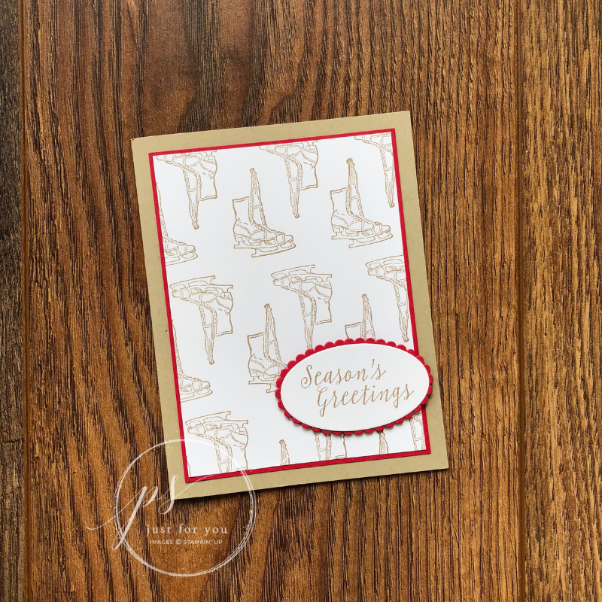

**Supplies:**

**Stamp Sets:** Cambridge Carols (147790 - wood mount; 147787 - clear mount)

**Ink:** Crumb Cake (147116) Classic Stampin’ Pad

**Paper:** Whisper White (100730), Crumb Cake (120953), & Real Red (102482) Cardstock

**Other:** SNAIL Adhesive (104332), Stamparatus (146276), Big Shot (143263), Layering Ovals Framelits (141706), Stampin’ Dimensionals (104430), Simply Scored Scoring Tool (122234), Small Grid Paper (149621)

**Measurements:**

* + Crumb Cake: 5-1/2” x 8-1/2”, scored and folded at 4-1/4” (card base)
  + Whisper White: 4-7/8” x 3-5/8” + scrap for sentiment oval
  + Real Red: 5” x 3-3/4” + scrap for scalloped oval

**Instructions:**

1. Stamp the sentiment onto the scrap piece of Whisper White cardstock using Crumb Cake Classic Ink.
2. Die cut the Crumb Cake sentiment piece using the Big Shot and the appropriately sized Layering Oval framelit. Die cut a scalloped oval using Real Red cardstock and the die that is just slightly bigger than the sentiment oval. Glue these together with SNAIL and set aside.
3. Place a piece of the Stamparatus small grid paper on your Stamparatus base plate. The instructions that follow assume that the side plate is on the left side of the tool, and that you are using your left hand to stamp.
4. Mount the skate stamp to the Stamparatus plate in the upper third of the plate, close to the centre. This is important because you will be moving the plate down the hinges. The paper will be moved sideways. You can use the gridlines to help make sure that stamp is straight. Before stamping on your cardstock, it is good practice to stamp onto the grid paper to ensure that the stamp is straight.
5. Once you are satisfied that your stamp is straight, place your Whisper White cardstock onto the base plate and secure with magnets. Make sure that the left corner of the cardstock lines up with a corner of one of the boxes on the grid paper. It doesn’t matter which one.
6. You will need to stamp the skates in a repeating pattern by moving the plate on the Stamparatus hinges, inking up the stamp before each press into the paper. To do this, stamp your first image. Lift the plate until it is vertical, pick it up out of the tool, move it down TWO hinges, and place it back into the hinge groove. You can then ink/stamp the skates again. Repeat this step again.
7. Move the plate all the way back to your starting point, but leave it open. Move your cardstock 6 squares (1-1/2”) to the left. Repeat step 6.
8. Move the plate all the way back to your starting point, leaving it open. Move your cardstock 12 squares (3”) to the right. Repeat step 6. You should have three long rows of skates.
9. Fully clean the stamp and ensure that it’s dry before continuing.
10. Mount the skate stamp to the Stamparatus, in approximately the same position as before, but it now needs to be upside down. To determine the stamp’s exact position when starting, make sure you place it on the stamped cardstock and then lower the plate to secure the stamp to the tool. Repeat step 5 - try to come as close to the corner as possible, but if you can’t, make a small line on the grid paper, and measure based on this line.
11. Repeat steps 6-8.
12. Glue the stamped piece of Whisper White paper to the Real Red cardstock, and adhere the entire layer to the card using SNAIL.
13. Adhere the sentiment to the card using Stampin’ Dimensionals.